Contents

Lab 6: CMD Lab - Scripting 2

Screenshot of “labs6.bat” 2

Screenshot of 'lab6FirstnameSurname.txt' 3

Lab 7: Git Intro 3

Screenshot of your file in the participants folder on GitHub 3

Screenshot of your name in participantsList.txt on GitHub 4

A record of your commits (go to the list of commits and screenshot your additions) 4

Lab 8 & 9: Binary and Hex Numbers 5

Task 1: 5

1. 5

2. 6

3. 7

Task 3: 8

Lab 10: Docker Research Assignment 9

Labs 6-10 Submission:

# Lab 6: CMD Lab - Scripting

## Screenshot of “labs6.bat”

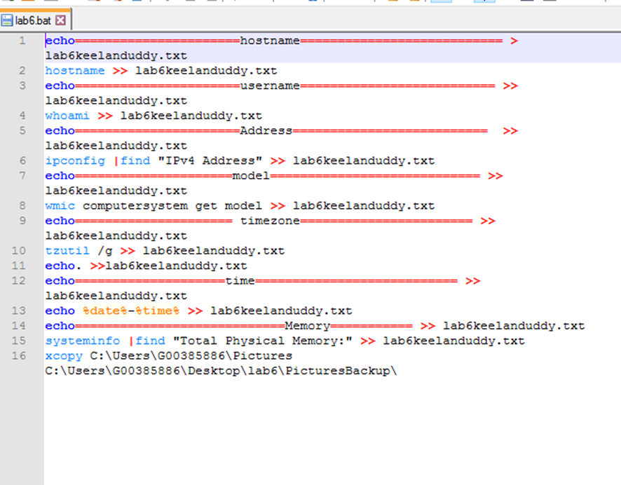

## Screenshot of 'lab6FirstnameSurname.txt'

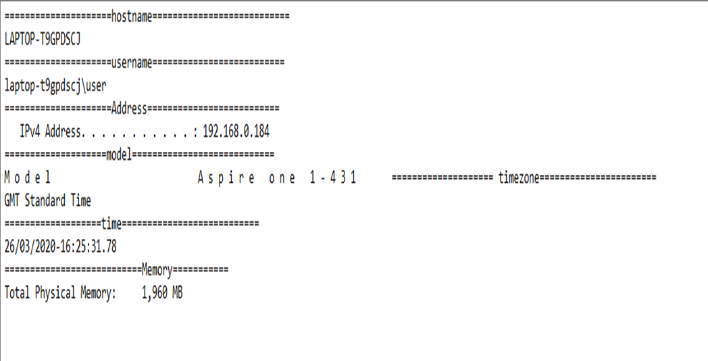

# Lab 7: Git Intro

## Screenshot of your file in the participants folder on GitHub

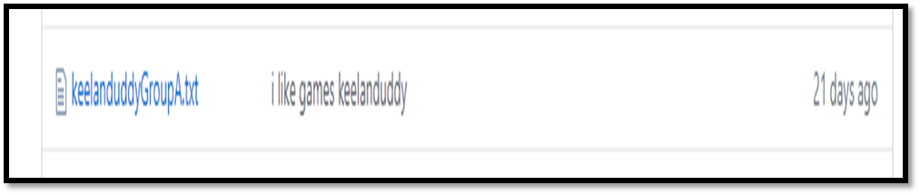

## Screenshot of your name in participantsList.txt on GitHub



## A record of your commits (go to the list of commits and screenshot your additions)

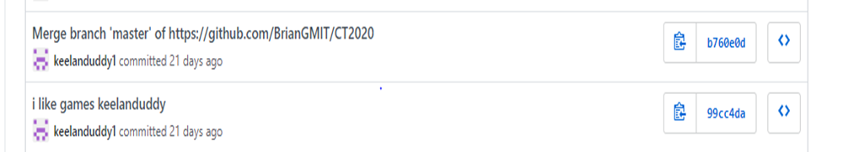

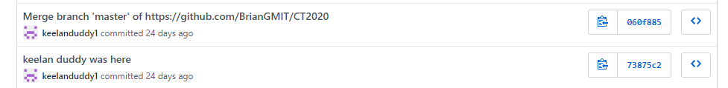

(the full record of my commits needed to do twice.)

# Lab 8 & 9: Binary and Hex Numbers

## Task 1:

Mohamed Salah. Date of Birth: 15/06/92

Wikipedia: born 15 June 1992 is an Egyptian professional footballer who plays as a forward for Premier League club Liverpool and the Egypt national team. Considered one of the best players in the world, he is known for his finishing, dribbling, and speed.

### 1.

ASCII:

|  |
| --- |
| 1 |
| 00110001 |
| HEX: 31 |

|  |
| --- |
| 5 |
| 00110101 |
| Hex: 35 |

|  |
| --- |
| 0 |
| 00110000 |
| HEX:30 |

|  |
| --- |
| 6 |
| 00110110 |
| HEX:36 |

|  |
| --- |
| 2 |
| 00110010 |
| HEX: 32 |

|  |
| --- |
| 9 |
| 00111001 |
| HEX:39 |

2.

|  |
| --- |
| 1 |
| 0001 |
| Hex: 1 |

|  |
| --- |
| 5 |
| 0101 |
| HEX:5 |

|  |
| --- |
| 0 |
| 0000 |
| Hex: 0 |

|  |
| --- |
| 6 |
| 0110 |
| Hex: 6 |

|  |
| --- |
| 9 |
| 1001 |
| HEX: 9 |

|  |
| --- |
| 2 |
| 0010 |
| Hex: 2 |

(a)

4 bits is enough to represent every digit between the numbers of 0-9. 4 bits can hold all hexadecimal digits. That is why we use 4 bits per digit.

3.

Dividing each by 2:

|  |  |
| --- | --- |
| 150692 |  |
| 75346 | 0 |
| 37673 | 0 |
| 18836.5 | 1 |
| 9418 | 0 |
| 4709 | 0 |
| 2354.5 | 1 |
| 1177 | 0 |
| 588.5 | 1 |
| 294 | 0 |
| 147 | 0 |
| 73.5 | 1 |
| 36.5 | 1 |
| 18 | 0 |
| 9 | 0 |
| 4.5 | 1 |
| 2 | 0 |
| 1 | 0 |
| 0.5 | 1 |

Ans: 0010 0100 1100 1010 0100

Hex: 2 4 C A 4

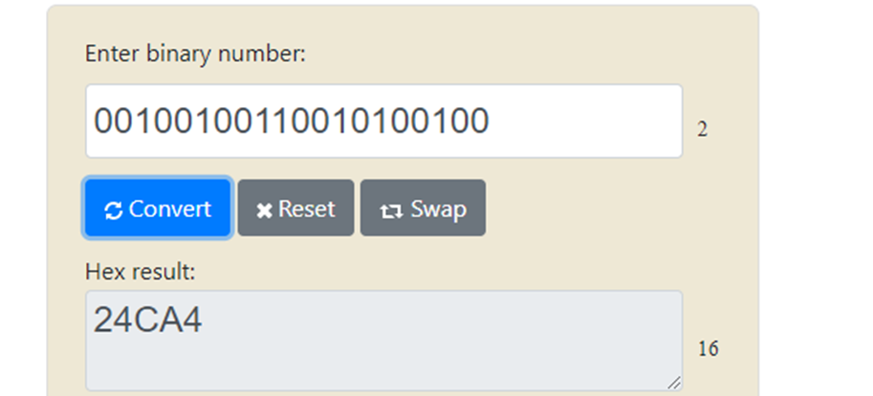

Maximum and Minimum bits:

01/01/00 = 14 bits

31/12/99 = 19 bits

Task 3:

1.

|  |  |  |  |  |  |  |
| --- | --- | --- | --- | --- | --- | --- |
| Carries | 1 | 1 | 0 | 1 | 1 | 0 |
|  |  |  | 1 | 0 | 1 | 1 |
| + |  | 1 | 1 | 0 | 1 | 1 |
| = | 1 | 0 | 0 | 1 | 1 | 0 |

2.

0.11 = 0 + ½ + ¼

1.011 = 1 + 0/2 + ¼ + 1/8

# Lab 10: Docker Research Assignment

When a developers project is being designed on a machine it works perfectly on that machine. However sometimes when that project is transferred to another machine or server it fails to work or have the same optimization as it once did on the machine it was developed on.

Docker is a software development platform and is compatible with almost any programming language, it allows you to have these “containers” in which you seal your code into. It also provides the needed libraries, dependencies and operating system which creates the environment to run it.

These containers make the code portable and where ever it is put it will work exactly like how it worked on the machine it was developed on. Other containers such as the social ones allow you publish them publicly. Containers are live instances of Docker images, Docker images are read only files while containers can be interacted with and admins can adjust their conditions/settings.

Docker provides the same functionality as a virtual machine. However it eliminates the guest OS containers making it more lightweight, faster and occupy less memory space.

Dockerfile: Which is a text file with instructions where in you input commands to assemble the Docker Image.

DockerImage: contains the application which you can execute, when ran it becomes an instance of a container. It is made up of layers in which a developer can make changes or create a new top layer. You can build them or pull them from a common repositories.